Agricultural Adaptation to Climate Change

CLIMATE CHANGE:
WHAT IS IT?
Climate change is defined as change in climate over time, whether due to natural variability or as a result of human activity. It is one of the most important global environmental challenges faced by humanity. The effects of climate change depend on the adaptive capacity and vulnerability of a particular system.
Adaptive capacity is the ability of a system to adjust to climate change (including climate variability and extremes) to moderate potential damages, to take advantage of opportunities, to cope with the consequences.
Whereas, the degree of susceptibility of a system to the effect of climate change and inability to cope with the adverse effects including climate variability is known as its vulnerability.

HOW DOES IT AFFECT ME?

- Climate change has implications on food production, natural eco-systems, fresh water supply and health.
- Regional changes in climate have contributed to various changes in physical and biological systems. These include the rise in air temperature leading to rapid melting of glaciers and increment of glacier lakes, changes in rainfall frequency and intensity, shifts in the growing season, early flowering of trees and emergence of insects, and shifts in the distribution ranges of plants and animals in response to changes in climatic conditions.
- Extreme climate events including flooding, heavy rainfall, droughts, heat wave and cold stream are also the consequences of climate change.

HOW TO OVERCOME ITS IMPACT?
Adverse impact of climate change mainly in agriculture can be overcome by the approach of adaptation, conservation agriculture and agro-forestry

Cropping Pattern: Change observed and adaptation:
- Cropping pattern refers to the proportionate area under different crops during an agricultural year and growing season refers to the period between bud burst and leaf fall.
- No cropping pattern can be good for all times to come. But there is often a tendency for the cropping pattern to stabilize over a period of time in different agro-climatically homogeneous farming area. However, with the change in climate most prominent observation is the change in the length of growing season.
- Thus to overcome the effect of climate change in the crops and receive the optimum benefits, cropping pattern has to be changed adaptation agriculture has to be adopted.
- Example, in Nepal Himalayas, potatoes harvesting was shifted from Mid-March to Mid-January, while leafy vegetables was shifted by 15 days in July, August and September, respectively. The agriculture yield has been improved and the farmers reported a shift in growing time of vegetables.
Adaptation:
Adaptation mainly aims to minimize peoples’ vulnerability by improving their ability to cope with the impacts of climate change. Adaptive capacity is often limited, particularly in poor rural areas where people live on subsistence agriculture. The communities have to be provided with climate change-related information and new adaptation strategies and measures have to be integrated into existing capacities, assets and resources. Understanding the climatic changes is necessary in order to adapt to the climatic changes. Information is required on short-term and long-term impact of climatic changes so that farmers can use different strategies and measures.

Adopting indigenous strategies to tackle change in cropping, harvesting, heavy rainfall or snowfall, such as:
- Covering vegetables with bamboo nets
With the change in temperature condition, incidence of pest and insect infestation also increases. Vegetable fields are routinely devastated by insects and extended drought conditions. Small holding farmers can combat this issue through simple technique of using bamboo net barriers.
Use of simple mosquito net with the available bamboo can manage insect pests and also maintain the micro-climatic conditions of that area of cultivable land.
- Cultivating before rainy season and after snowfall
Adjustment of planting date or changing in cropping calendar is important to minimize the effect of temperature and sustaining the yield. Planting before rainy season will allow more effective use of soil moisture received from rainwater likewise if planting is done after snowfall, this will also efficiently utilize the soil moisture formed by snow melting.

- Digging deep for planting to protect from snowfall
Sub-freezing temperatures can cause heavy injury to the roots of the plants. If the roots are not deep, they often get exposed to alternate freezing and thawing of the ground. Heavy ice and snow can cause snapping of roots and ultimately death of the plants. This kind of injury to the plants can be prevented by increasing the depth of sowing/planting. When the seeds are placed at increased depth in the ground, the root system gets penetrated deep into the soil. This protects roots from extreme cold temperatures in case of snowfall.

- Mulching
Mulching is cultural practice often recommended in the cultivation of vegetables and mulch is a protective covering usually of leaves or straws placed around the plants. Spreading dry leaves over crops control the water losses due to transpiration.
- Placing sticks to act as support to prevent crops from falling down due to heavy rainfall.
Heavy and unpredicted rainfall, strong wind and other adverse weather condition could be resultant of expected climate change. Simple and cultural way to save the standing crop from falling down due to heavy rainfall would be placing sticks for the support.

A study carried out on sorghum, helps to give an insight into the possible impacts of climate change. The study focused on winter and monsoon crops of sorghum in three different climate zones of India: central (CZ), south-central (SCZ) and south-west (SWZ). An increased temperature will most likely lead to an overall decrease in crop production. By 2020, monsoon sorghum production was predicted to decrease by 14% in CZ and SWZ and by 2 % in SCZ, whereas winter sorghum production was estimated to decrease by up to 7%. Low cost adaptation strategies, like changing variety and sowing date, could reduce the impact and vulnerability of winter sorghum and help maintain the productivity of sorghum under changing climatic conditions.

Conservation Agriculture
Conservation Agriculture is a method of farming that conserves, improves, and ensures efficient use of natural resources. It aims to help farmers achieve profits with sustained production levels while conserving the environment. Traditional methods of farming cannot cope with the increasing needs of the ever expanding human and livestock populations. Conservation actions stop and reverse land degradation, boost productivity and contribute to reducing land degradation and increasing food security. The steps and associated principles are outlined below.

- Conservation Tillage with minimum soil disturbance: Conservation Tillage with minimum soil disturbance:
Tillage aims to create a soil environment favorable to plant growth; however conservation tillage refers to disturbing the soil only where the seed, fertilizer and manure are to be placed. No tillage, minimum tillage, reduced tillage and mulch tillage are terms synonymous with conservation tillage.
Conservation tillage:
- Reduces destruction of the soil structure
- Does not expose soil to wind and water erosion
- Improves water infiltration rates
- Slows the rate at which organic matter is mineralized and oxidized, so organic matter build-up occurs
- Causes little disruption to the organisms that live in the soil
- Saves time, energy, and money because less land is tilled
- Reduces soil compaction because the crop plant roots are left undisturbed.
Conservation Agriculture improves yields, protects soil, increases soil moisture and restores soil fertility. Conservation Agriculture reduces production cost, cuts costs on labor and fertilizer while increasing their yields.
- Permanent Soil Cover:
Soil is better protected from the physical impact of water, wind and direct insolation (exposure to the sun) when it is covered. Soil can be covered with previous-crop residues or cover crops, which also increases biomass. This farming practice is one of the best ways to turn agricultural land into carbon sink.
- Helps reduce direct raindrop impact and so reduces soil erosion
- Helps reduce runoff and aids water to seep into the soil
- Reduces evaporation and conserves moisture for the crop
- Suppresses weeds emergence
- Organic residues improve organic matter content and soil nutrient status
- Provides a beneficial environment for soil organisms, such as worms and millipedes, that are important for biological tillage
- Moderates soil temperatures.

- Intercropping and Crop Rotation:

Intercropping
Intercropping is the cultivation of two or more crops simultaneously on the same field. Either both the crops can be sown at the same time in the same field or the second crop could be sow after the first crop has completed its development.

There are four (4) sub-categories of intercropping:

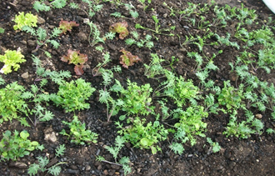
- Mixed Intercropping: Growing two or more crops simultaneously with no district row arrangement.
Example: Pumpkins, okra, cowpea and cucumber can be grown simultaneously on the same field with no distinct row arrangement.

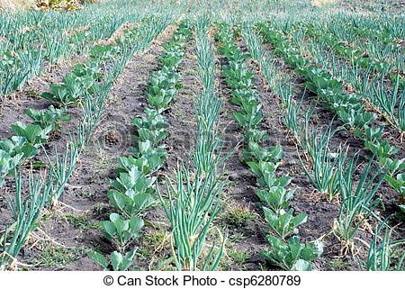
2. Row intercropping: Row intercropping is the growing of two or more crops at the same time with at least one crop planted in rows. When all the crops are grown in rows a specific ratio is maintained. Example: Wheat and mustard, wheat and pea

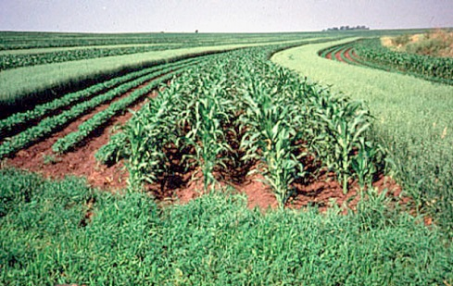
3. Strip cropping: Growing of two or more crops of different families at the same time in small portions arranged side by side. It is ideal for vegetables. The crops should be grown wide enough to permit separate crop production using machines but close enough for the crops to interact.
Example: Alternating strips of wheat, corn and soybean 6 rows wide each.
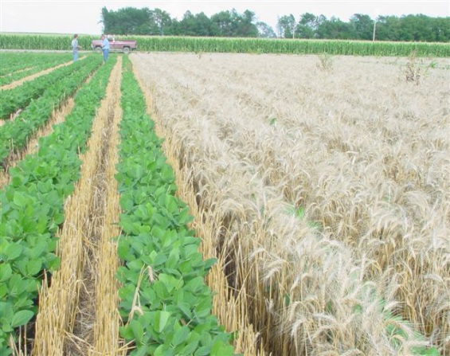
4. Relay Intercropping: Planting a second crop into a standing crop at a time when the standing crop is at its reproductive stage but before harvesting.
Example: Intercropping soybean with ripened winter wheat

Advantages of intercropping
- Replenishes soil fertility: intercropping with nitrogen-fixing legumes adds ‘top-dressing Fertilizer’ to the soil
- Enables crops to use the nutrients in the soil more effectively
- Helps to control weeds, diseases and pests by breaking their life cycles through the introduction of a new crop
- Reduces the risk of total crop failure in case of drought and disease outbreak.
- Reduces the plant diseases. The distance between plants of the same species is increased because other crops (belonging to a different family group) are planted in between.
- Results in potential increase for total production and farm profitability than when the same crops are grown separately.
- Provides 2 or more different food crops for the farm family in one cropping season.
- Reduces the insect/mite pest populations because of the diversity of the crops grown. When other crops are present in the field, the insect/mite pests are confused and they need more time to look for their favorite plants.
- Utilizes the farm area more efficiently.

Crop rotation
The system of varying successive crops in a definite order on the same ground is called a crop rotation. They involve changing the type of crop grown in one area on a regular basis.

Advantages of crop rotation
- Crop rotations prevent the buildup of pests and diseases. When the same crop is grown for successive years, the eggs of insects and disease causing pathogen remain in the soil and keep flourishing. When the crop is changed every year, buildup of these pests can be avoided. As a result it reduces reliance on synthetic chemicals
- They help to maintain soil fertility. When a crop is grown for successive years same nutrients get used up and their content depletes. Crop rotation replenishes the soil nutrients.

  - Agro-forestry
Agroforestry refers to growing trees together with other agricultural crops and animals, with benefits to plants, animals, people, and the environment. It combines agricultural and forestry technologies to create more diverse, productive, profitable, healthy, and sustainable land-use systems.

The use of trees for soil conservation and gully reclamation has been achieving good results in high altitudes across other parts of the world. These practices involve establishment of woodlots, protective hedges and live fences around homesteads and home gardens. Both food and non-food, including fodder tree species and trees for fuel wood and construction material, can be used. An Agro-forestry system has the potential to fight the aberrations due to climate change.

The selection of appropriate agro-forestry systems is usually based on existing practices, climate, soil conditions, the level of soil erosion, livestock population, availability of pastures, household food supply and nutrition, and fuel wood requirements. Features of the mountains to be taken care include the increasing land degradation and decreasing carrying capacity of the land, and the severely cold winters, often accompanied by strong winds, snow and frost. Since most fast growing tree and shrub species do not tolerate these conditions, there are few or no trees to shelter or protect livestock from the cold, and there is little in the form of fuel wood for the local communities to warm themselves.

The suggested measures are as follows:
- Homestead gardens and orchards: this system involves the establishment of small orchards or the scattered planting of individual fruit trees in the home garden, inter-planted with various vegetables. In the mountains, fruit species that can tolerate the climatic conditions can be used e.g. stone, pome fruit, and nut species.

- Windbreaks: establishing windbreaks in the mountains may be more difficult than elsewhere due to the very cold winters and the short growing season, and requires a long-term perspective. It may be preferable to establish windbreaks around homesteads and gardens rather than around fields, for protection of homes and gardens against cold, strong winds. Windbreaks may also protect the soil against wind erosion.

- Hedges and live fences: problems of trespassing are much higher in the lowlands than the mountains, but nevertheless, it is advisable to establish protective hedges and live fences around homesteads, especially against livestock kept within the village. Species that can be used in the production of medicinal products can be grown.

- Fodder banks/trees on contour strips in cultivated fields: this system is more applicable to the areas where grazing resources are poor. In arid and semi-arid lands, leaves and edible twigs of trees and shrubs can constitute well over 50 percent of the biomass production. At high altitudes, tree foliage may provide over 50 percent of the feed available to ruminants in the dry season, branches being harvested and carried to the animals. Even in regions of higher rainfall where grass supplies the major proportion of the dry matter eaten by ruminants, tree leaves and fruits can form an important constituent of the diet, particularly for small ruminants. These trees could be planted in rows intercropped with herbaceous annual or perennial fodder crops.

- Gully rehabilitation: the extent of soil erosion in the cold deserts is critical. Some erosion control and donga reclamation work has taken place in parts of these areas. A combination of tree, shrub, grass and herbaceous plant species may be used. Willows and poplars, amongst other species, can be planted on the gully floor where there is likely to be sufficient moisture to support tree establishment.

4.4. Case lets of Farm Production Adaptations
The different practices that can be adopted by the farmers also relate to Farm Production Adaptations such as Change in crops, Change in crop variety, Diversifying crops, Changes in timing of cultivation and Water Management. The case lets given below are specific examples of Farm Production adaptations to climate change.

Changes in timing of cultivation
Changes in the cultivation timing have been observed among the farmers in Africa who would nurse seedlings in the last two weeks of September and transplant them in the first two weeks of October. Faced with the problem of climate change (especially prolonged rains), the nursing period has moved from the last two weeks of September to the last two weeks of October with effective transplanting of seedlings in November. Due to the delayed rainfall in most zones, crop farmers are engaging in late planting by about a month and repeated planting of crops in response to the erratic rainfall. This is being practiced for maize, millet and Cucurbitaceous (Cucumeropsisedulis) and other cereal crops.

Change in crops
Farmers alter/replace the crop varieties in their farms with cultivars which are able to cope better with drought and other weather extremes. Crops with high yield variability (e.g. wheat or maize) are substituted by crops with lower productivity but more stable yields (e.g. fodder or sorghum). In Zimbabwe farmers have switched successfully to more drought tolerant crops in areas where the frequent recurrence of droughts has made agriculture production difficult using the traditional crop varieties.

Water Management
Water Management Techniques include altering amounts and timing of irrigation, improved irrigation technologies and structural measures. Under the Irrigation Ordinance of Sri Lanka, the Administrative Head of District Public Service (a government agent) is empowered to hold water management meetings prior to each season. During the meeting, farmers discuss the type of crop to be grown during the season and the timing of the first release of water and the final release of water. The final decisions reflect the extent of water in the main reservoir, and the probability of further rains as the season proceeds.

Weather-related services at LAC
These measures for Adaptation to Climate Change are possible when long-range and short-range weather forecasts are made available to farmers. The data gathered through MAAS and the weather monitoring services provided to farmers by the AAs in the LAC will enable them to interpret the data and advice farmers accordingly. The farmers can then overcome the impacts of climate change by taking these measures.
Such advisory service providing information on weather has been a success in India from nearly 70 years when the All India Radio started broadcasting the farmers’ weather forecast.
The latest service of this kind is the Integrated Agro-Meteorological Advisory Service (IAAS) was introduced in 2007.The agricultural advisories currently reach some 2.5 million smallholder farmers across India. Studies have shown that farmers receiving IAAS advisories have yields that are 10–15% higher, and costs that are 2–5% lower, than farmers not receiving the advisories, largely as a result of using more modern agricultural production technologies and practices, having better irrigation and pest/disease management and improved postharvest technologies.

